1.Odd String Difference

Code:

#include <stdio.h>

char\* findOddString(char\*\* words, int wordsSize) {

int n = strlen(words[0]); // Get length of first string

// Calculate difference array for the first string

int diff[n - 1];

for (int i = 0; i < n - 1; i++) {

diff[i] = words[0][i + 1] - words[0][i];

}

// Iterate through remaining strings and compare difference arrays

for (int i = 1; i < wordsSize; i++) {

for (int j = 0; j < n - 1; j++) {

if (words[i][j + 1] - words[i][j] != diff[j]) {

return words[i]; // Mismatch found, return the odd string

}

}

}

// If no mismatch found, return the first string (unlikely)

return words[0];

}

int main() {

char\* words1[] = {"acd", "aef", "bcd"};

char\* words2[] = {"a", "b", "c", "d"};

char\* words3[] = {"aaa", "aab", "aac"};

int n1 = sizeof(words1) / sizeof(words1[0]);

int n2 = sizeof(words2) / sizeof(words2[0]);

int n3 = sizeof(words3) / sizeof(words3[0]);

printf("Odd string in words1: %s\n", findOddString(words1, n1));

printf("Odd string in words2: %s\n", findOddString(words2, n2));

printf("Odd string in words3: %s\n", findOddString(words3, n3));

return 0;

}

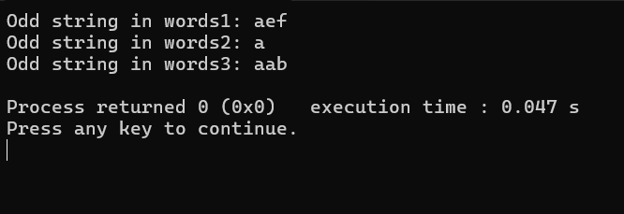

2.Words Within Two Edits of Dictionary

Code:

#include <stdio.h>

#include <stdlib.h>

#include <string.h>

int isEditDistanceOne(char \*s1, char \*s2) {

int m = strlen(s1);

int n = strlen(s2);

if (abs(m - n) > 1)

return 0;

int count = 0;

int i = 0, j = 0;

while (i < m && j < n) {

if (s1[i] != s2[j]) {

if (count == 1)

return 0;

if (m > n)

i++;

else if (m < n)

j++;

else {

i++;

j++;

}

count++;

} else {

i++;

j++;

}

}

if (i < m || j < n)

count++;

return count == 1;

}

int isEditDistanceTwo(char \*s1, char \*s2) {

int m = strlen(s1);

int n = strlen(s2);

if (abs(m - n) > 2)

return 0;

int count = 0;

int i = 0, j = 0;

while (i < m && j < n) {

if (s1[i] != s2[j]) {

if (count == 2)

return 0;

if (m > n)

i++;

else if (m < n)

j++;

else {

i++;

j++;

}

count++;

} else {

i++;

j++;

}

}

if (i < m || j < n)

count++;

return count == 2;

}

char\*\* findWords(char\*\* queries, int queriesSize, char\*\* dictionary, int dictionarySize, int\* returnSize) {

\*returnSize = 0;

char \*\*result = (char \*\*)malloc(queriesSize \* sizeof(char \*));

for (int i = 0; i < queriesSize; i++) {

for (int j = 0; j < dictionarySize; j++) {

if (strcmp(queries[i], dictionary[j]) == 0 || isEditDistanceOne(queries[i], dictionary[j]) || isEditDistanceTwo(queries[i], dictionary[j])) {

result[\*returnSize] = (char \*)malloc((strlen(queries[i]) + 1) \* sizeof(char));

strcpy(result[\*returnSize], queries[i]);

(\*returnSize)++;

break;

}

}

}

return result;

}

int main() {

char \*queries[] = {"word", "note", "ants", "wood"};

int queriesSize = sizeof(queries) / sizeof(queries[0]);

char \*dictionary[] = {"wood", "joke", "moat"};

int dictionarySize = sizeof(dictionary) / sizeof(dictionary[0]);

int returnSize = 0;

char \*\*result = findWords(queries, queriesSize, dictionary, dictionarySize, &returnSize);

printf("Output: [");

for (int i = 0; i < returnSize; i++) {

printf("%s", result[i]);

if (i < returnSize - 1)

printf(", ");

}

printf("]\n");

// Free dynamically allocated memory

for (int i = 0; i < returnSize; i++) {

free(result[i]);

}

free(result);

return 0;

}

Output:

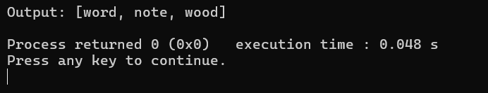

3.Next Greater Element IV

Code:

#include <stdio.h>

#include <stdlib.h>

int\* nextGreaterElement(int\* nums, int numsSize, int\* returnSize) {

int\* result = (int\*)malloc(numsSize \* sizeof(int));

\*returnSize = numsSize;

for (int i = 0; i < numsSize; i++) {

result[i] = -1;

for (int j = i + 1; j < numsSize; j++) {

if (nums[j] > nums[i]) {

result[i] = nums[j];

break;

}

}

}

return result;

}

int main() {

int nums[] = {2, 4, 0, 9, 6};

int numsSize = sizeof(nums) / sizeof(nums[0]);

int returnSize;

int\* result = nextGreaterElement(nums, numsSize, &returnSize);

printf("Output: [");

for (int i = 0; i < returnSize - 1; i++) {

printf("%d, ", result[i]);

}

printf("%d]\n", result[returnSize - 1]);

free(result);

    return 0;

}

Output:

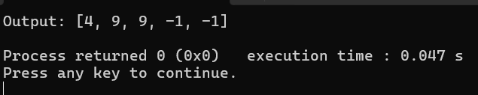

4.Minimum Addition to Make Integer Beautiful

Code:

#include <stdio.h>

int minAddToMakeBeautiful(int n, int target) {

int sum = 0;

while (n > 0) {

sum += n % 10;

n /= 10;

}

return sum > target ? sum - target : 0;

}

int main() {

int n1 = 16, target1 = 6;

int n2 = 467, target2 = 6;

int n3 = 1, target3 = 1;

printf("Output 1: %d\n", minAddToMakeBeautiful(n1, target1));

printf("Output 2: %d\n", minAddToMakeBeautiful(n2, target2));

printf("Output 3: %d\n", minAddToMakeBeautiful(n3, target3));

    return 0;

}

Output:

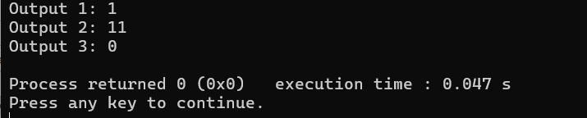

5.Sort Array by Moving Items to Empty Space

Code:

#include <stdio.h>

int minOperations(int\* nums, int numsSize) {

int start = 0, end = numsSize - 1, moves = 0;

while (start < end) {

if (nums[start] == 0) {

start++;

} else if (nums[end] != 0) {

end--;

} else {

nums[start] = 0;

moves++;

}

}

return moves;

}

int main() {

int nums1[] = {4, 2, 0, 3, 1};

int nums2[] = {1, 2, 3, 4, 0};

int nums3[] = {1, 0, 2, 4, 3};

int size1 = sizeof(nums1) / sizeof(nums1[0]);

int size2 = sizeof(nums2) / sizeof(nums2[0]);

int size3 = sizeof(nums3) / sizeof(nums3[0]);

printf("Output 1: %d\n", minOperations(nums1, size1));

printf("Output 2: %d\n", minOperations(nums2, size2));

printf("Output 3: %d\n", minOperations(nums3, size3));

    return 0;

}

Output:

